EYFS | Year 1 | Year 2 | Year 3 | Year 4 | Year 5 | Year 6
Autumn 1  Narrative  Information texts including:  Explanation  Non chronological  Poetry  Journalistic writing  Persuasion  Biography  Instructions  Playscripts | Autumn 1  Lost in the Toy Museum  Narrative - Write an alternative version  Press Play  Instructions | The magic Porridge pot  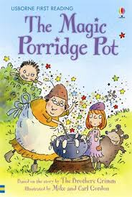  Parallel texts Pie Corbett’s books fairy tales  Narrative  The great Jam Sandwich  Instructions | Autumn 1  Narrative – create own Mr Men character and story  Used as a stimulus for descriptive writing  Stone Age Boy  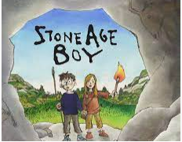  Narrative | Autumn 1  The Tin Forest  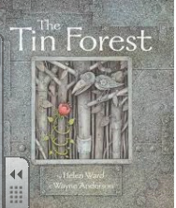  To create a setting  Non chronological report –  How to train your dragon  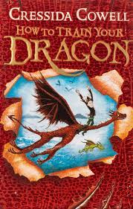 | Autumn 1  Sound collector  Poetry – senses collecter  The Wilderness War / palytime should not be shortened (Every two years)  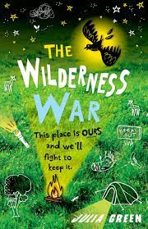  Persuasion – save our environment | Autumn 1  The Arrival  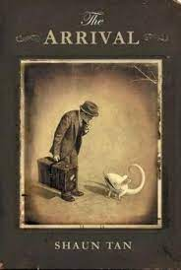  Narrative  Fantastic Beasts  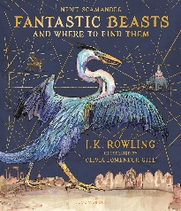  Non chronological report
Autumn 2 | Autumn 2  Dear Greenpeace  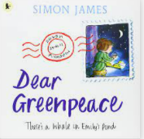  Write a letter  The Jolly Christmas Postman  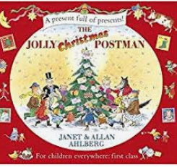  Narrative Write own version of story | Autumn 2  ZIm Zam Zoom  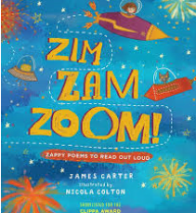  To write a verse linked to fireworks  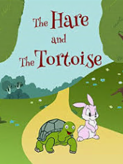  Parallel text Aesops fables  Write alternative version of the story.  Information text | Autumn 2  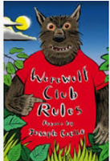  Write and perform poem  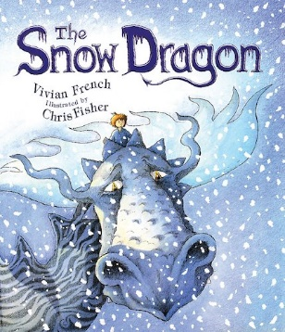  Playscripts | Autumn 2  Hurricane  Narrative – write own version of the story  Poetry from around the world Haikus Cinquains range of forms | Autumn 2  Journey to Jo’Burg - Beverley Naido  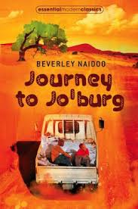  Write an epilogue  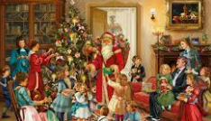  Non – chronological report  Victorian Christmas | Autumn 2  Secrets of a Sun King  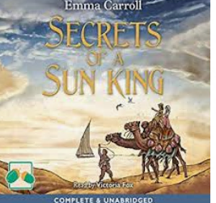  First person narrative of someone entering the mysterious tomb  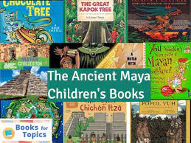  Ancient Maya  Persuasive
 |  |  |  |  | Illustrated Book Awards

