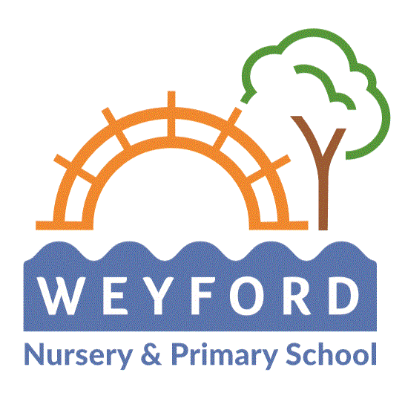

Writing Policy

At Weyford Nursery and Primary we believe writing is a key aspect of the curriculum and along with reading, speaking and listening, it makes a significant contribution to the development of children as thinkers, learners and effective communicators. It is part of the school’s ethos that all pupils develop their writing ability across a range of genres and enjoy the process of developing this lifelong skill. At Weyford Nursery and Primary Academy we strive to provide children with exciting, purposeful and inspiring contexts in which to become writers through access to high quality texts.

Aims

- To encourage the development of an enjoyment of writing amongst pupils, and a recognition of its value through:
- Providing a stimulating curriculum and school environment, which places the development of writing skills at its heart.
- Providing meaningful contexts and quality texts as the inspiration for writing.
- Allowing children to demonstrate the ability to choose the appropriate form and content to suit the purpose and audience for their writing.
- To ensure the teaching of Writing is effectively planned, and responsive to learners’ needs, through:
- Planning the teaching of both Writing composition and Spelling, Punctuation and Grammar (SPAG) in conjunction with the National Curriculum
- Employing effective assessment procedures (both formative and summative)
- To best enable the development of the development of writing skills, through preceding Writing with quality Speaking and Listening / Drama activities.
- To provide pupils with a clear model for how to meet lesson objectives and thereby become effective writers through delivering:
- Clear and regular teacher modelling of the thought processes and standards required.
- Interactive and engaging Writing sessions
- Guided Writing sessions targeted to the needs of groups of learners.

We aim to develop, through our teaching of writing, the following attitudes:

- Curiosity and interest;
- Pleasure and thoughtfulness;
- Critical appraisal;
- Independence;
- Confidence;
- Perseverance;
- Imagination.

At Weyford Primary and Nursery Academy, writing is taught and celebrated in a range of ways, Writer of the Week and writing on display, and is taught daily across the school across a range of subjects.

We follow the National Curriculum which ensures that a range of genres are covered, including narrative (e.g. extended stories, stories by the same author, myths and legends, adventure stories and traditional stories), non-fiction (e.g. persuasive texts, non-chronological reports, information texts, recounts, reports and letters) and poetry (e.g. rhyme, nonsense rhymes, shape poems, acrostic and descriptive poetry). Genres are taught and learnt considering the:
- purpose
- form
- audience

Throughout each unit, the links between reading and writing are made explicit – we read as writers and we write as readers. The progress throughout each unit of work shows the transition between reading as writers (focusing on structure, characterisation, and language features etc…) to writing as readers (word play, describing, composition, planning, editing, revising etc…).

Within the learning journey we plan opportunities for children to carry out Site of Application writes, where they put into practice skills learnt from the previous units. Apprentice writes allow for independent and sustained practice of the genre studied.

Writing is taught in a range of ways:

Modelling Writing
The teacher talks aloud the thought processes as a writer. They model strategies in front of the children, communicating the strategies being used. Teachers may model writing skills such as punctuation, rehearsal, proof reading, editing, word selection, sentence construction and paragraphing.

Shared Writing
This is a collaborative approach in which the pupils contribute their ideas and thoughts for the teacher to write. The teacher models and teaches specific writing skills and there is the opportunity for discussion to choose the most effective or suitable ideas.

Supported Composition
The children work in pairs to provide the next sentence of the text. This may follow from the modelled or the shared writing process.

Guided Writing
Pupils are grouped dependent on assessment for learning from the lesson before or during the lesson being taught. The teacher or other adult works with the group on a carefully selected task appropriate to that group’s needs and targets. This will focus on a particular aspect of the writing process rather than writing a complete piece.

Independent Writing
Children are given opportunities to apply their understanding of the text type in their own writing. They are encouraged to plan, draft, write, edit and assess their work, applying the skills they have learnt throughout the unit of work on that particular genre.

The teaching and learning of writing varies across the age range in school. In the early years emergent writing is encouraged through the use of different writing materials, including felt tipped pens, crayons, chalk, sand, magnetic letters, big brushes, water, paint and computers, as well as writing in the role-play areas, such as postcards, menus, invitations, labels etc… Alongside this, children take part in activities to encourage and develop gross and fine motor skills necessary to write in a legible script.

Daily phonics lessons build their phonic and spelling knowledge to enable them to sound out words and spell high frequency words correctly. Children throughout the year groups have spellings to learn relevant to their age, and these focus on high frequency words or a particular spelling pattern.

As children progress throughout the school, they are given many opportunities to write independently and to apply the skills they have learnt and practised in shared and guided writing. Wherever possible, writing is made meaningful by being planned for a specific purpose or in response to a particular experience.

Vocabulary, grammar and punctuation is planned and taught as an integral part of each unit of work. The objectives are carefully matched to the unit of work to enable them to be taught and learnt within a meaningful context.

Assessment and Record Keeping

Assessment is used to inform the planning and teaching of reading. Assessment ius broken down in toi the following domains:
- Transcription
- Handwriting
- Composition: Composition and effect
- Composition: Text structure and organisation
- Composition: Sentence structure
- Vocabulary, grammar and punctuation

Writing throughout the school and how it reflects this policy will also be reviewed throughout the year in the following ways:

- Governor’s work scrutiny;
- SLT/staff work scrutiny;
- EYFS/KS1/KS2 external moderation;
- EYFS/KS1/KS2 internal moderation;
- Moderation with other schools;
- Learning walks.
- Tests, mocks and analysis of outcomes

Policy updated October 2022

Agreed by the Governing Body……………………………………………………

Signed………………………………………………………………. Chair of Governors

